1 Introduction 1
2 Scope and field of application 1
3 Definitions and Abbreviations 1
4 References 2
5 Angular 3
5.1 Introduction 3
5.2 Architecture Overview 3
6 AngularCLI 3
6.1 Introduction 4
6.2 Features 4
6.3 Angular Bootstrap 4
6.4 Angular Testing 4
6.5 Angular Production 5
6.5.1 Target 5
6.5.2 Enviroments 5
6.6 Angular CLI’s Features 5
7 Webpack 6
8 Redux 6
8.1 Introduction 7
8.2 Key Ideas 7
9 HTML5 MSMClient 8
9.1 New Structure 8
9.2 App folder 8
9.3 Layout 9
9.4 API 9
10 Technical Specification 9
10.1 Languages 9
10.2 Layout 10
10.3 Menu 10
10.4 Site Tree View 10
10.5 Dashboard 11
10.5.1 Map View 11
10.5.2 List View 12
10.6 Inspect Module 12
10.7 Analyze Module 13
10.8 View Option 14
10.9 System Config Module 14
10.10 Help Function 14

DOCUMENT CHANGE RECORD

Rev. | Date | Author | Nature of revision
1.0 | 13 .11.2017 | Ruby Pham | Initial Revision

Introduction
This document describes the MSMClient structure and new technologies to build the MSMClient .

Scope and field of application

Definitions and Abbreviations
MSM - Multisite Monitor
CLI - Command Line Interface
JSON - Java Script Object Notation

References

Angular

Introduction

Angular is a platform that makes it easy to build applications with the web. Angular combines declarative templates, dependency injection, end to end tooling, and integrated best practices to solve development challenges. Angular empowers developers to build applications that live on the web, mobile, or the desktop.

Architecture Overview
Angular is a framework for building client applications in HTML and either JavaScript or a language like Typescript that compiles to JavaScript.
The framework consists of several libraries, some of them core and some optional.
You write Angular applications by composing HTML templates with Angularized markup, writing component classes to manage those templates, adding application logic in services, and boxing components and services in modules.
Then you launch the app by bootstrapping the root module. Angular takes over, presenting your application content in a browser and responding to user interactions according to the instructions you've provided.
Of course, there is more to it than this. You'll learn the details in the pages that follow. For now, focus on the big picture.
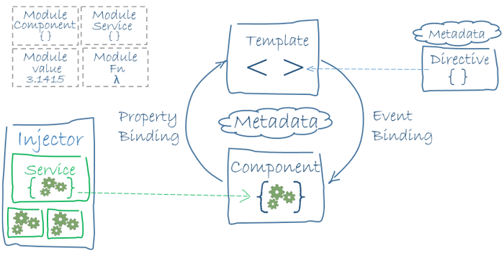

AngularCLI

Introduction
Angular CLI is a Command Line Interface (CLI) to automate your development workflow. It allows you to:
- Create a new Angular application.
- Run a development server with LiveReload support to preview your application during development.
- Add features to your existing Angular application.
- Run your application’s unit tests.
- Run your application’s end-to-end (E2E) tests.
- Build your application for deployment to production.

Features

- Creating a New Angular Application
  - ng new my-app
- Install packages
  - Npm install
- Running Your Application
  - ng serve/npm install
- Adding Features to Your Application
  - ng generate class my-new-class: add a class to your application
  - ng generate component my-new-component: add a component to your application
  - ng generate directive my-new-directive: add a directive to your application
  - ng generate enum my-new-enum: add an enum to your application
  - ng generate module my-new-module: add a module to your application
  - ng generate pipe my-new-pipe: add a pipe to your application
  - ng generate service my-new-service: add a service to your application

Angular Bootstrap
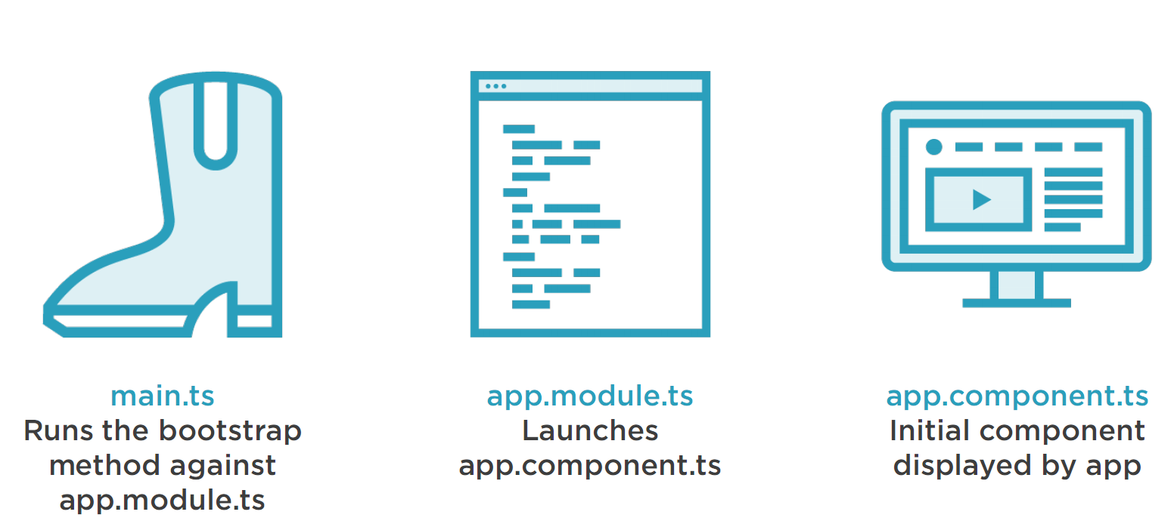

Angular Testing
- Running Your Unit Tests
  - Ng test
  - Angular CLI automatically configures the Karma test runner for you when your application is initially created.
- Running Your End-to-end (E2E) Tests
  - Ng e2e
  - Angular CLI automatically configures Protractor for you when your application is initially created.

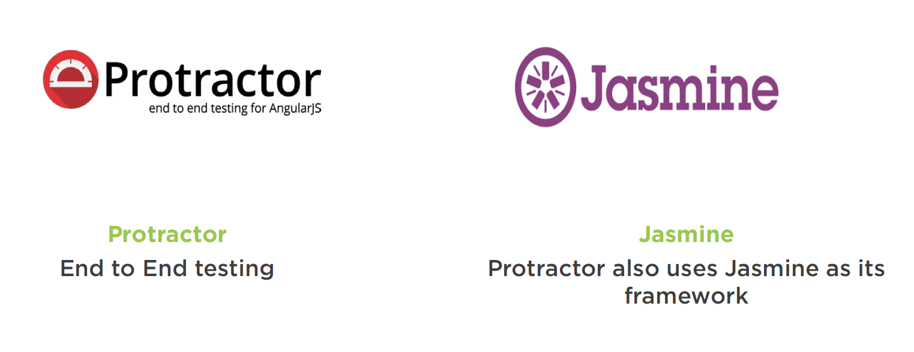

Angular Production
Running ng serve builds and bundles your Angular application automatically to a virtual filesystem during development.
However, when your application is ready for production, you will need real files that you can deploy to your server or to the cloud.
To build and bundle your application for deployment, run:
$ ng build

Target
Specifying a target impacts the way the build process operates. Its value can be one of the following:
- development: default mode, do not minify or uglify code
- production: minify and uglify code
Building your application in production mode:
$ ng build --target=production

Enviroments
If you specify a different environment, the build process will use the corresponding environment:
# Uses environments/environment.ts
$ ng build

# Also uses environments/environment.ts
$ ng build --environment=dev

# Uses environments/environment.prod.ts
$ ng build --environment=prod

Angular CLI’s Features
Angular CLI’s roadmap contains many exciting upcoming features:
- Progressive Web App (PWA) Support
Angular CLI will be able to create a Web Application Manifest for you, generate an App Shell and provide Service Worker scripts to cache your application data.
Learn more about mobile support here.
- Refactoring Support
In addition to adding features to your application, Angular CLI will also let you refactor existing features, for example, moving a component or renaming a service.
- Upgrade Support
Angular CLI will be able to help you with Angular upgrades. Because Angular CLI has a semantic understanding of your application, it will be able to help you with code changes that are required when upgrading to a newer version of Angular.
- Extensibility
Improved extensibility support so you can create your own custom add-ons and deployment scripts.
- Increased Performance
Improved performance so Angular CLI becomes faster.
- Library Developer Mode
In addition to creating a new application, Angular CLI will also let you create a new library that can be consumed by others.
- Some of these features are already partially available. Check out the GitHub repository if you want to play around with them.

Webpack
- Is a module bundler
- Takes modules with dependencies and generates static assets representing those modules.
- Complies SCSS/LESS.
- TypeScript transpilation.
- Bundles JavaScript, CSS.
- Asset optimization.
- Virtual filesystem for assets.
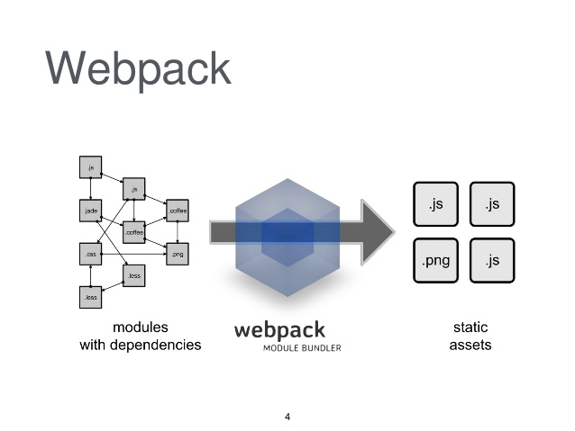

Redux

Introduction
Redux is a predictable state container for JavaScript apps.
It helps you write applications that behave consistently, run in different environments (client, server, and native), and are easy to test. On top of that, it provides a great developer experience, such as live code editing combined with a time traveling debugger.
You can use Redux together with React, Angular or with any other view library.

Key Ideas
The key ideas of Redux are this:
- All of your application’s data is in a single data structure called the state which is held in the store
- Your app reads the state from this store
- This store is never mutated directly
- User interaction (and other code) fires actions which describe what happened
- A new state is created by combining the old state and the action by a function called the reducer.
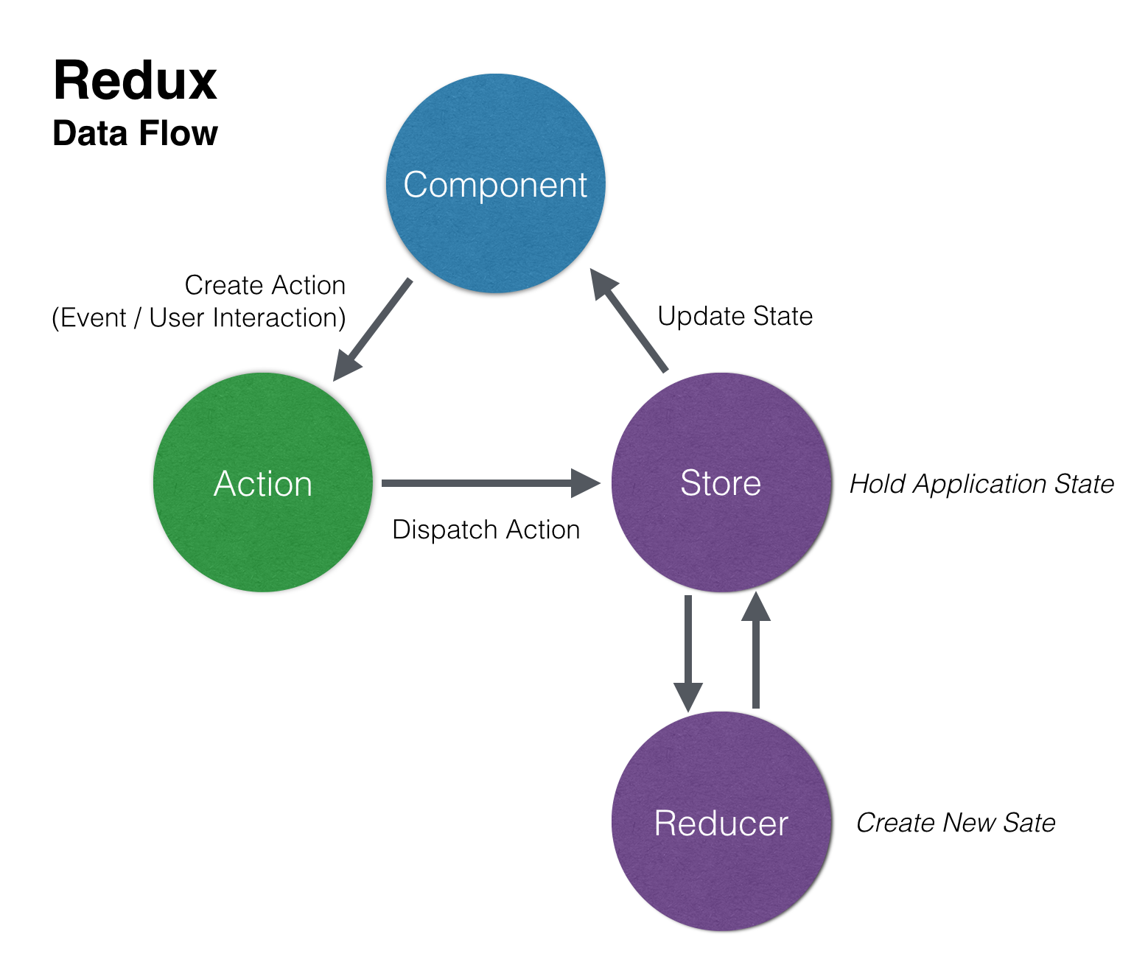

HTML5 MSMClient

New Structure

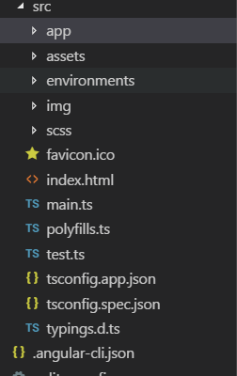 | App: Manage source code.  Assets: Manage css, fonts and images.  Enviroments: Manage dev or production enviroment.  Scss: Manage scss.

App folder

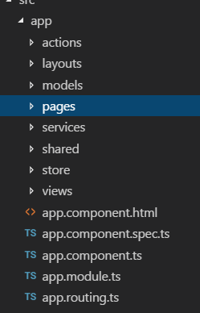 | Actions: Manage redux actions.  Layouts: Manage page layout.  Models: Manage msmclient models.  Pages: Manage pages (ex: login, register, 404, 500 pages).  Services: Manage services.  Shared: Manage shared files (ex: menu, sidebar, dropdown).  Store: Manage redux stores.  Views: Manage msmclient views (ex: site tree view, inspect, alarm, list view).

Layout
We will use this template http://coreui.io/angular/, and customize the colors to make it consistence to msmclient.

Please follow the UI guidelines for references:

https://elno1git01/DefaultCollection/_git/HTML5%20MSMClient?path=%2FDocuments&version=GBmaster&_a=contents

API
I recommend to create new Restful API for HTML5 because the Silverlight API is not generic and rely on Entity objects too much.

I found lot of duplicated codes in the services for these files, as well as the functionality of firmware upload, configuration part, and static map.

It would be better if we can reorganize these files and make it more generic, more inheritance and follow the SOLID principles.

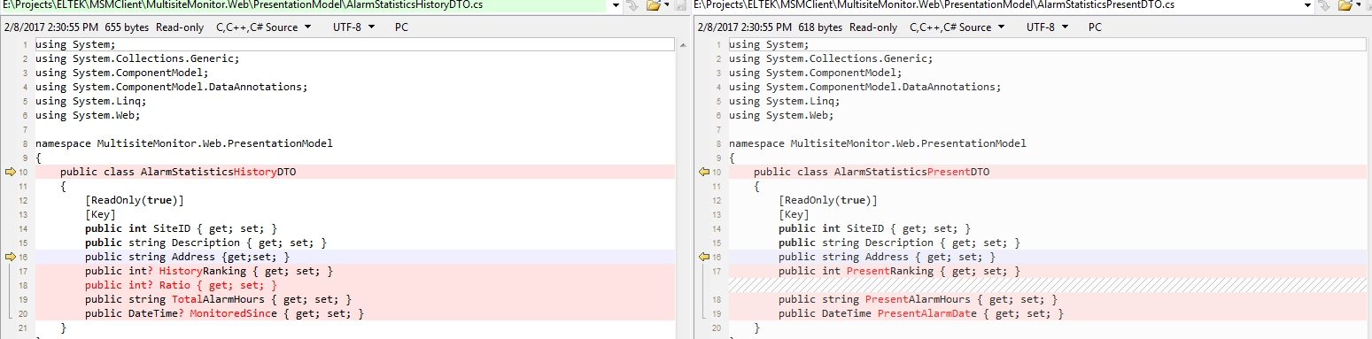

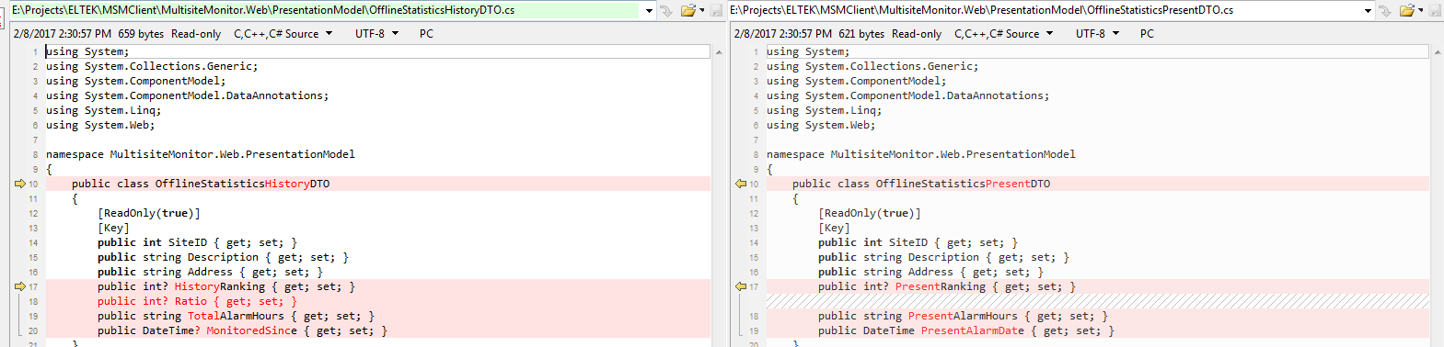

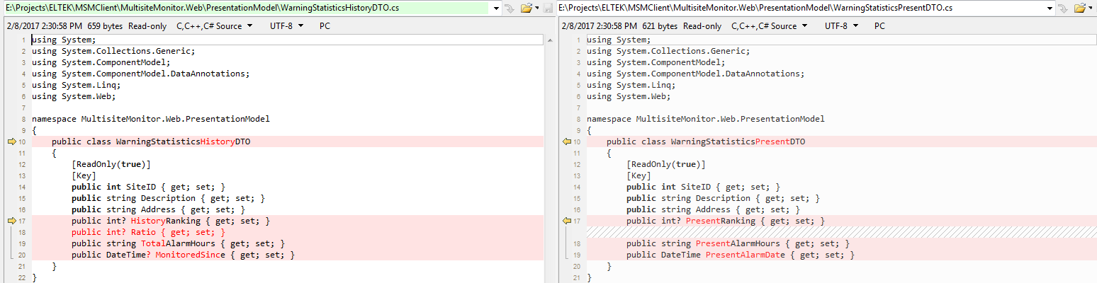

Technical Specification

Languages
The HTML5 MSMClient will support 3 languages:English, Norwegian and French. These resources are saved in the resouces files, where all text information are loaded from. Note that we also need 3 version fore each image: English, Norwegian and French content.

Layout

The layout is divided into 4 regions:
- The top region is the menu region, short sites information (total no of sites, sites offline, sites in alarm, solar power yesterday and work in progress)
- The left region is the sites and site groups’ information.
- The center region is the main content, that display all appropriate views.
- The bottom region is the rolling alarm view.

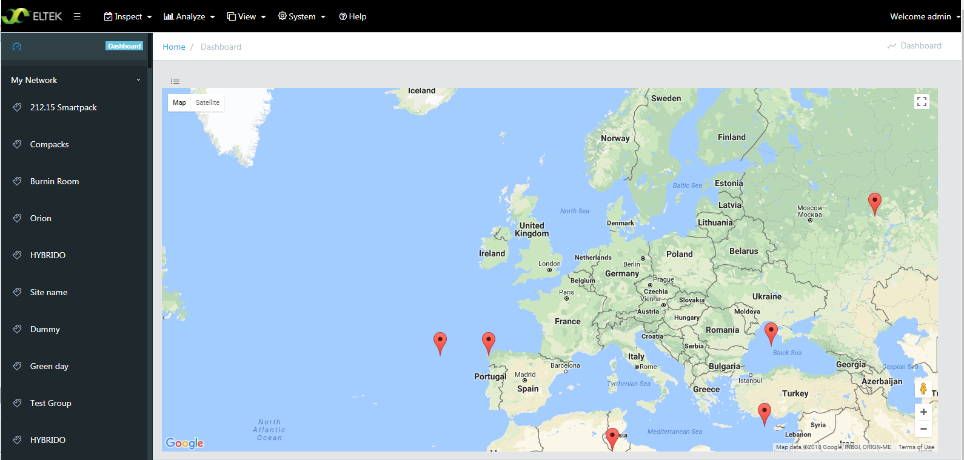

Menu
Silverlight version:

Following the silverlight version, the menu also include these parts: inspect, analyze, view, system and help.
For the hierarchy of these menus, please refer the silverlight version.

Site Tree View
The sites is loaded from the restricted site API, get the hierarchy and display the structure to UI.
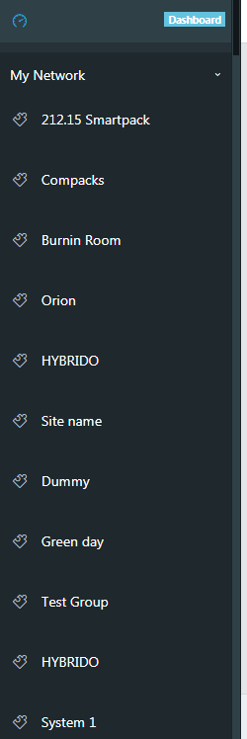

Dashboard

Map View

The map view displays sites’ indicator and information: battery, load, rectifier, feul and solar.

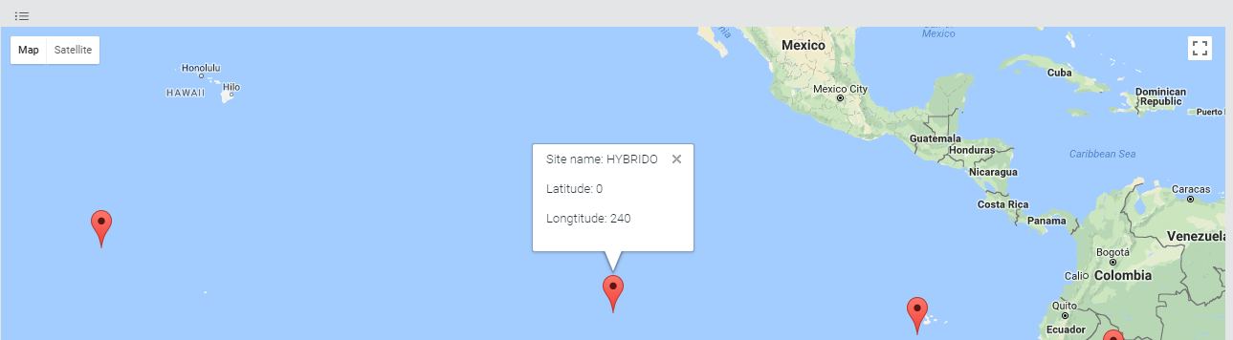

You can switch to the list view by clicking the list-view icon and vice versa.

Note that I am using the google map, and it should be placed by the bing map.

List View

The list view displays sites’ information: name, ip address, controller type, no of active alarm, no of warning alarm, no of offline alarm,.., and last sucessful polling.

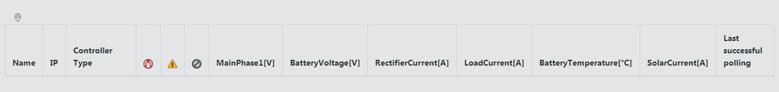

Inspect Module
Following the Silverlight version, this module includes these parts:
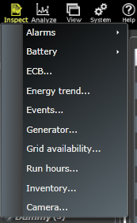

There will be a component for each part underneath the Inspect folder. You also need to define the root Inspect module, and config the routing. Please refer the ../views/inspect for more details: 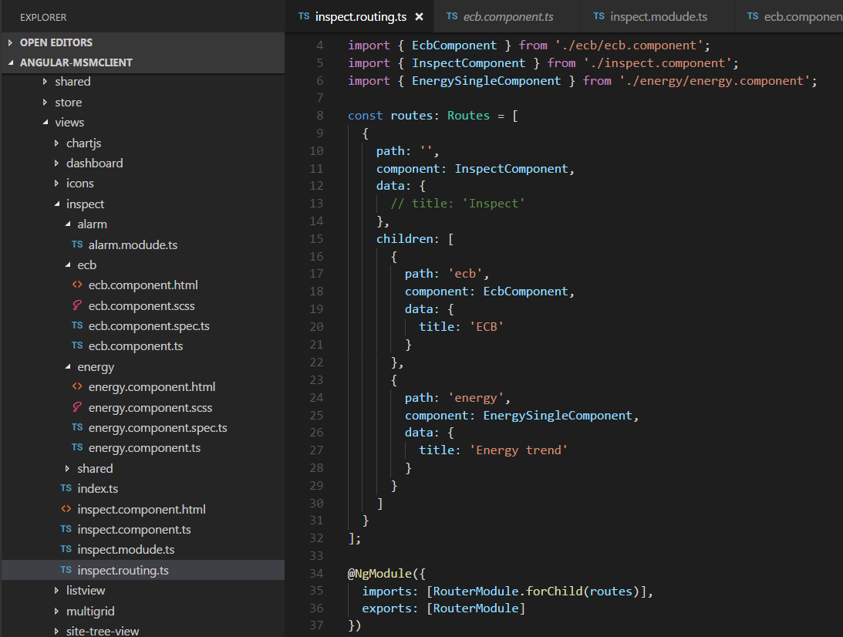

When everything is done, don’t forget to register the module in the root app routing:

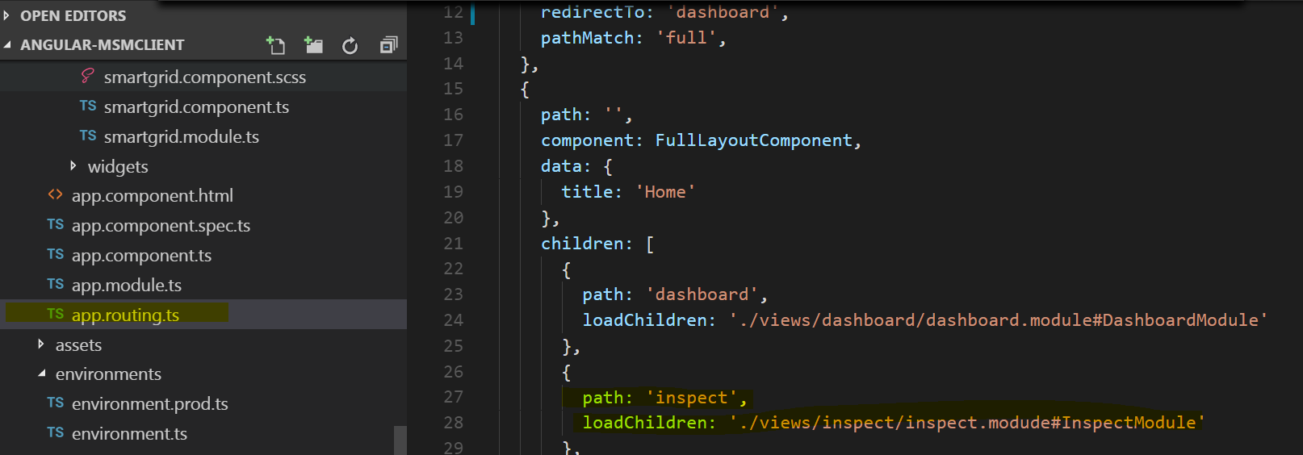

Analyze Module
Following the Silverlight version, this module includes these parts:

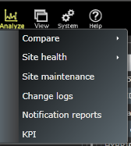

There will be a component for each part underneath the Analyze folder. You also need to define the root Analyze module, and config the routing. Please take a look at the Inspect module for references.

View Option
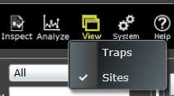

There will be a component for each part underneath the Option folder. You also need to define the root Option module, and config the routing as well. Please take a look at the Inspect module for references.

System Config Module
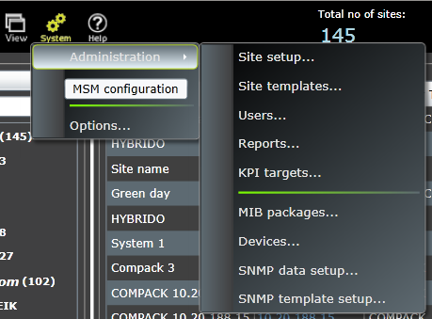

There will be a component for each part underneath the System folder. You also need to define the root System module, and config the routing as well. Please take a look at the Inspect module for refeences.

Help Function
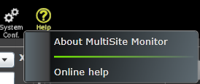

There will be a component for each part underneath the Help folder. You also need to define the root Help module, and config the routing as well. Please take a look at the Inspect module for references.

